**Designing New Products using Choice Models in R**

When creating a new product like this Chevrolet Silverado, designers often face tough decisions. Should the truck have a smaller bed so that we can give more leg room to the passengers?

* Should we make the truck larger, even though the fuel economy will go down?
* Should we make the truck larger, even though the fuel economy will go down?

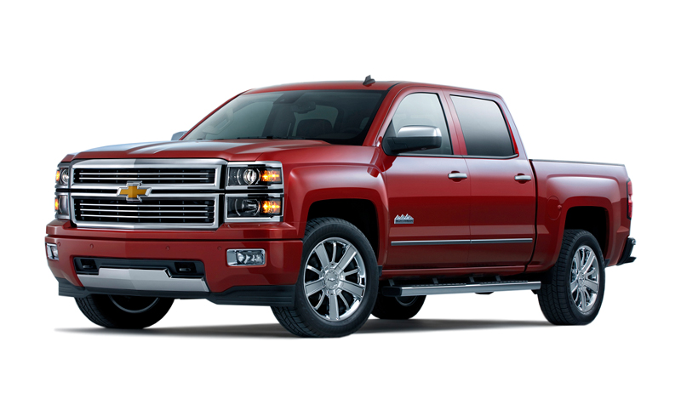

Finding the voice of the customer

Better designers spend time talking to potential customers about what they want and that is *sort-of* helpful.

But customers typically want “everything”

Key idea

1. Ask customers to choose from among alternative designs (something consumers do every day).
2. Use a choice model to *infer* their preferences from the choices.
3. *Predict* whether they will buy alternative designs using the model.

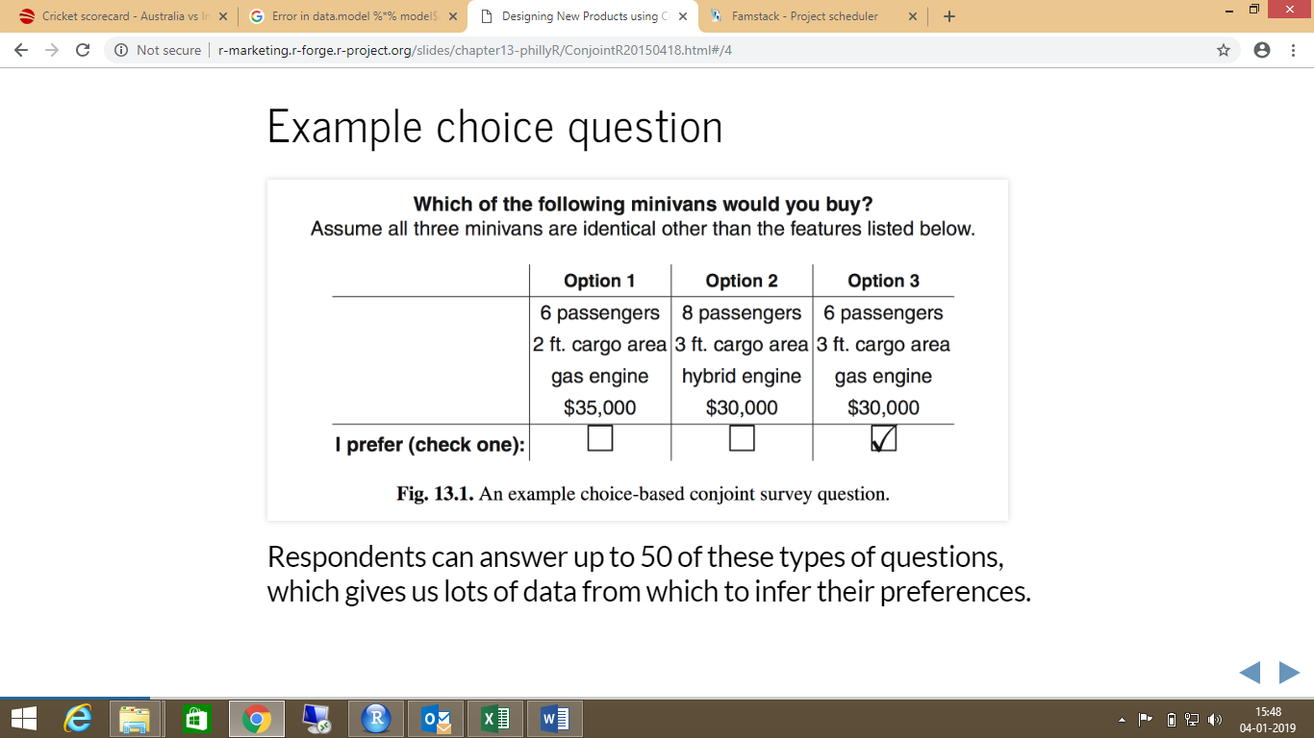

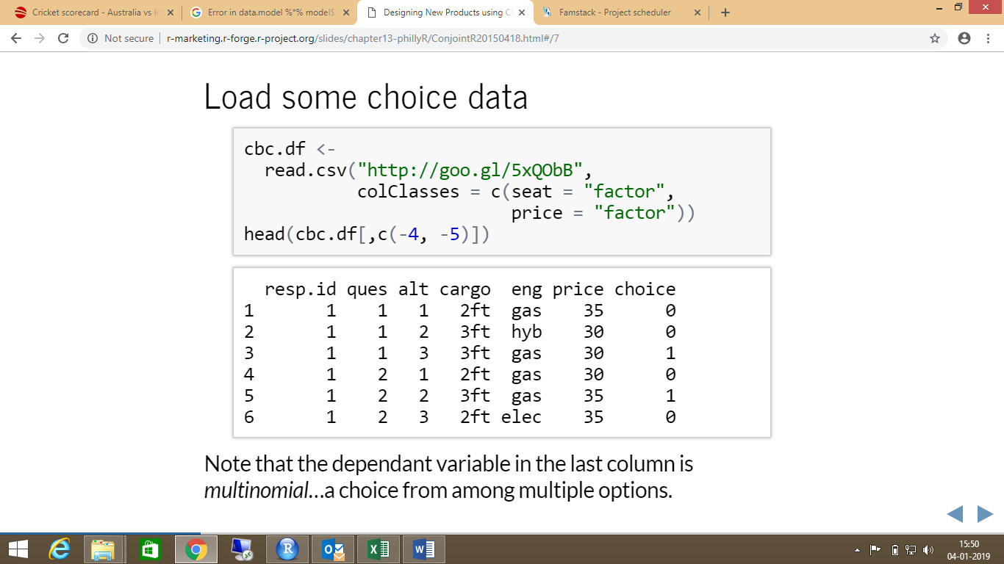

Why model?

* As with any other multivariate data set, looking at univariate marginal summaries only tells part of the story.
* While we can see that customers tend to choose 6-seat minivans and tend to choose gas engines, it is hard to say whether seats or engines has a stronger influence on choice.
  + What if in the survey the 6-seat minivan options tended to have gas engines?
* As with many multivariate problems, the solution is a regression model (of a special type.)

**Willingness-to-pay**

In a model like m3 where we estimate a single parameter for price, we can compute the average willingness-to-pay for a particular level of an attribute by dividing the coefficient for that level by the price coefficient.

 So, on average, customers are willing to pay $2750 more for 3ft of cargo space versus 2ft.